IHE Change Proposal

Tracking information:
IHE Domain | PCC
Change Proposal ID: | CP-PCC-210-00
Change Proposal Status: | Rejected
Date of last update: | February 16, 2015
Person assigned: | George Cole

Change Proposal Summary information:
Deprecation of extension sdtc:patient
Submitter’s Name(s) and e-mail address(es): | George Cole (george.cole@allscripts.com)
Submission Date: | February 16, 2015
Integration Profile(s) affected:
Actor(s) affected: | None
IHE Technical Framework or Supplement modified: | PCC TF Vol 2 Revision 10 October 2014
Volume(s) and Section(s) affected: | PCC TF Vol 2 6.3.2.3.15
Rationale for Change: From HL7 SDWG meeting 02/12/2015 – identification of some extension in IHE PCC TF that HL7 SDWG will mark as deprecated include sdtc:patient

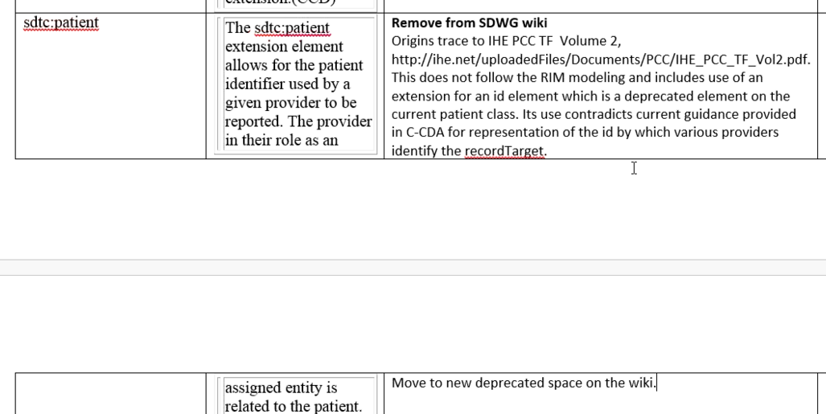

<sdtc:patient><sdtc:id root=' ' extension=' '/></sdtc:patient>
The <sdtc:patient> element may be present to represent the patient's medical record number with the given provider. The root attribute of <sdtc:id> element shall be present and identifies the namespace used for the identifier. The extension attribute shall be present and is the patient's medical record or account number with the provider. This element is an HL7 extension to CDA Release 2.0.

See A.5.2 Patient Identifier

2/24/15 – discussion with Lisa:
This is not the way in C-CDA to document the patient MRN, or multiple MRNs…..these should go into the patientRole

Note: this is also present in HITSP C83, 4.1.2 sdtc:patient
Question: was the extension added because of an old constraint on at most one id per patientRole?
Yes, this was a HITSP Constraint. 1.02 Person ID, Required, Not Repeating (R/N)

We had a discussion about this in IHE PCC this morning, and the update is: please do not deprecate this as it is believed to be correctly documented and used.

The history on this dates back into HITSP C83, where you’ll find the following:

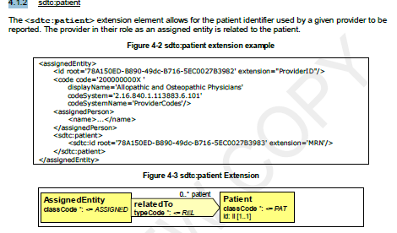
Which Keith claims tells us it is correctly implemented.

